gHiLetgo 3-01-0340 5V One Channel Relay Module

https://www.kleen-ritecorp.com/p-68993-hiletgo-3-01-0340-5v-one-channel-relay-module-relay-switch-with-opto-isolation-high-low-level-trigger.aspx?srsltid=AfmBOooaUIVaTKVusGp0d4QhHK5EQHCkCgRfELrsWHSuuogbgbwc4pxp

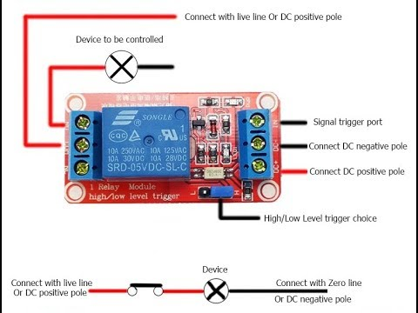
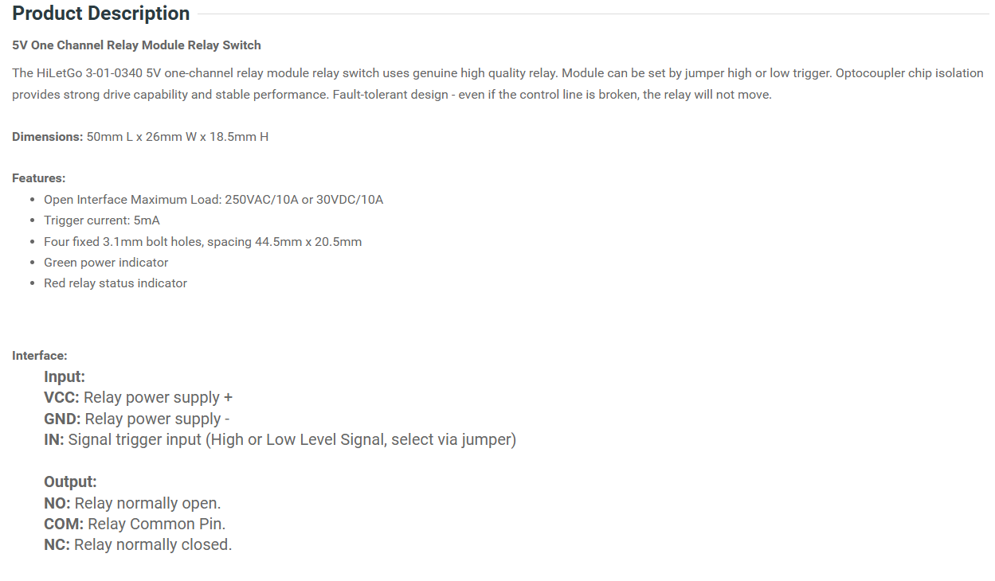

Module Power Supply AC-DC Converter
Acxico 5Pcs 5V 700mA Board Module Mini AC-DC 110V 120V 220V 230V to 5V 12V Converter Board Module Power Supply

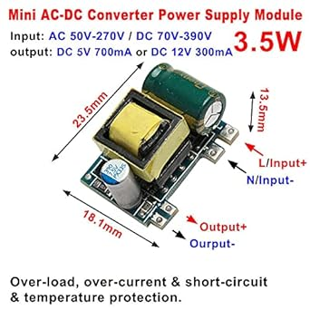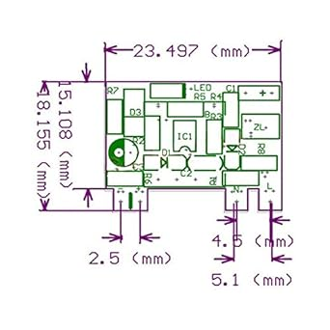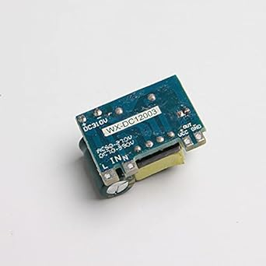
Description:The power supply is isolated industrial module power supply, with temperature protection, over-current protection and short circuit full protection, high and low voltage isolation, AC85 ~ 265V wide voltage input, 431 regulated DC5V output, small size, stable performance, high cost performance.Working temperature: -20 degree to 70 degrees C,The high level green gold capacitor has 105 degrees of temperature and 10 thousand hours.At 70 degrees, it is more than 5 years,At room temperature for about 20-50 years (not recommended for use above 70 degrees).Output fiter high quality solid capacitorThe installation of electronic modules requires basic knowledge and requires a certain electronic professional foundation and hands-on ability. Please purchase carefully!AC50-277V to DC 5V Specification:Input voltage range: AC50V-277V or DC70V-390VNo-load power: <0.05W (full load power. <4W)Output characteristics: multiple voltage modules can be used in parallel to meet the needs of small space and high current.Output voltage: 5V +-0.15V (no load and full load, light load minus 0 1V heary load srebound, 50 Percent load nipple 60mV)Output current: 5V0mA-700mA,(enter constant curtent mode when full load )Test resistance: 7 Q (4.9V) for 5VOutput indicator: green lightOutput power: 3.5W (ficiency is about 8090)Output protection: over voltage, over current, over temperature, over work, short circuit protection, etc.100 Percent new and high qualityWeight:30gQuantity:5PcsPackage Included:5Pcs 5V 700mA Board Module Mini AC-DC 110V 120V 220V 230V to 5V 12V Converter Board Module Power Supply(If there are any problems with the product, please send us pictures.Tell us more details about this problem)

- The power supply is isolated industrial module power supply, with temperature protection, over-current protection and short circuit full protection, high and low voltage isolation, AC85 ~ 265V wide voltage input, 431 regulated DC5V output, small size, stable performance, high cost performance.
- Working temperature: -20 degree to 70 degrees C,The high level green gold capacitor has 105 degrees of temperature and 10 thousand hours.
- The installation of electronic modules requires basic knowledge and requires a certain electronic professional foundation and hands-on ability. Please purchase carefully!
- Package Included:5Pcs 5V 700mA Board Module Mini AC-DC 110V 120V 220V 230V to 5V 12V Converter Board Module Power Supply(If there are any problems with the product, please send us pictures.Tell us more details about this problem)
- Thank you so much for your purchasing from our store.Any question ,please feel free to contact us.

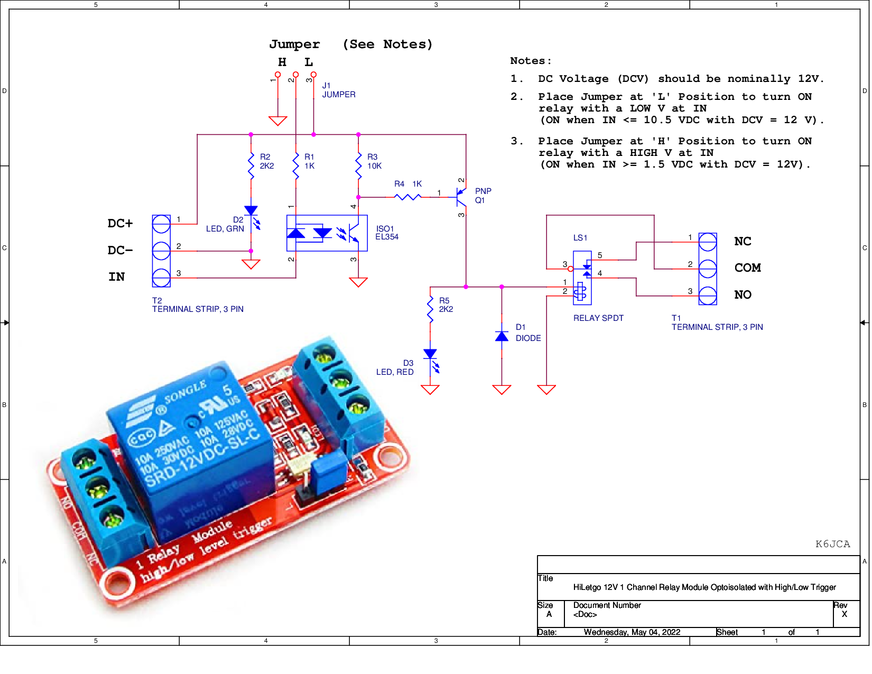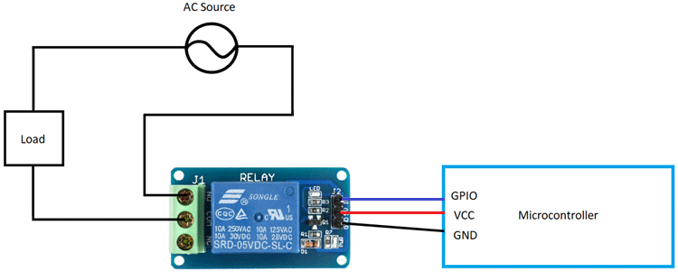

GPIOs

GPIO | Input | Output | Notes
0 | pulled up | OK | outputs PWM signal at boot, must be LOW to enter flashing mode
1 | TX pin | OK | debug output at boot
2 | OK | OK | connected to on-board LED, must be left floating or LOW to enter flashing mode
3 | OK | RX pin | HIGH at boot
4 | OK | OK
5 | OK | OK | outputs PWM signal at boot, strapping pin
6 | x | x | connected to the integrated SPI flash
7 | x | x | connected to the integrated SPI flash
8 | x | x | connected to the integrated SPI flash
9 | x | x | connected to the integrated SPI flash
10 | x | x | connected to the integrated SPI flash
11 | x | x | connected to the integrated SPI flash
12 | OK | OK | boot fails if pulled high, strapping pin
13 | OK | OK
14 | OK | OK | outputs PWM signal at boot
15 | OK | OK | outputs PWM signal at boot, strapping pin
16 | OK | OK
17 | OK | OK
18 | OK | OK
19 | OK | OK
21 | OK | OK
22 | OK | OK
23 | OK | OK
25 | OK | OK
26 | OK | OK
27 | OK | OK
32 | OK | OK
33 | OK | OK
34 | OK |  | input only
35 | OK |  | input only
36 | OK |  | input only
39 | OK |  | input only

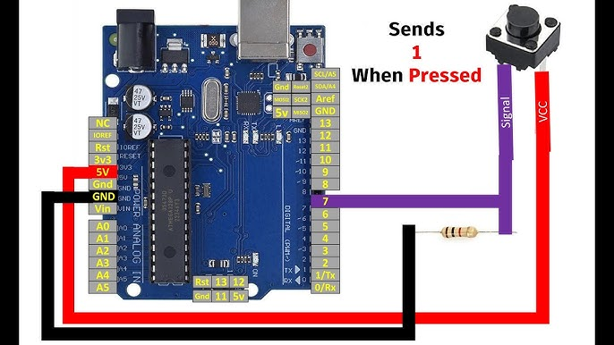
https://www.circuits-diy.com/control-led-with-push-button-arduino-tutorial/

